Backtracking & Approximation Algorithms
N-Queens, Sudoku Solver, Graph Coloring, Hamiltonian Cycle, Approximation Algorithms (Vertex Cover / Bin Packing)
Dr. ABIRAMI B

N-Queens Problem

1. Place N Queens on a Chessboard
Basic | Backtracking
Place N queens on an N × N chessboard such that no two queens attack each other. Display one valid arrangement.
Input:
N = 4
Expected Output:
One Valid Solution:
0 1 0 0
0 0 0 1
1 0 0 0
0 0 1 0

2. Find All Solutions of N-Queens
Medium | Backtracking
Find all possible ways to place N queens on an N × N chessboard.
Input:
N = 4
Expected Output:
Total Solutions = 2

Solution 1:
0 1 0 0
0 0 0 1
1 0 0 0
0 0 1 0

Solution 2:
0 0 1 0
1 0 0 0
0 0 0 1
0 1 0 0

3. Count Total N-Queens Solutions
Hard | Solution Counting
Determine the total number of valid solutions for the N-Queens problem.
Input:
N = 8
Expected Output:
Total Number of Solutions = 92

Sudoku Solver

4. Validate Sudoku Placement
Basic | Constraint Checking
Check whether a given number can be placed safely in a specified Sudoku cell.
Input:
Cell = (0,2)
Number = 4
Expected Output:
Safe Placement: YES

5. Solve a 9 × 9 Sudoku Puzzle
Medium | Backtracking
Solve the given Sudoku puzzle and display the completed grid.
Input:
Sudoku Grid:
5 3 0 0 7 0 0 0 0
6 0 0 1 9 5 0 0 0
0 9 8 0 0 0 0 6 0
8 0 0 0 6 0 0 0 3
4 0 0 8 0 3 0 0 1
7 0 0 0 2 0 0 0 6
0 6 0 0 0 0 2 8 0
0 0 0 4 1 9 0 0 5
0 0 0 0 8 0 0 7 9

Expected Output:
Solved Sudoku Grid:
5 3 4 6 7 8 9 1 2
6 7 2 1 9 5 3 4 8
1 9 8 3 4 2 5 6 7
8 5 9 7 6 1 4 2 3
4 2 6 8 5 3 7 9 1
7 1 3 9 2 4 8 5 6
9 6 1 5 3 7 2 8 4
2 8 7 4 1 9 6 3 5
3 4 5 2 8 6 1 7 9

6. Determine Whether Sudoku is Solvable
Hard | Feasibility Check
Determine whether a valid solution exists for the given Sudoku puzzle.
Input:
Partially Filled Sudoku Grid
Expected Output:
Sudoku Solvable: YES
Solution Found Successfully

Graph Coloring

7. Color a Graph Using M Colors
Basic | Graph Coloring
Assign colors to vertices such that no adjacent vertices have the same color.
Input:
Vertices = 4
M = 3

Adjacency Matrix:
0 1 1 1
1 0 1 0
1 1 0 1
1 0 1 0
Expected Output:
Vertex 0 → Color 1
Vertex 1 → Color 2
Vertex 2 → Color 3
Vertex 3 → Color 2

8. Determine Whether M-Coloring is Possible
Medium | Feasibility Check
Determine whether the graph can be colored using M colors.
Input:
Vertices = 5
M = 3

Edges:
(0,1) (0,2) (1,2) (1,3) (2,4)
Expected Output:
Graph can be colored using 3 colors.

9. Find Minimum Colors Required
Hard | Chromatic Number
Determine the minimum number of colors required to color the graph.
Input:
Complete Graph K4

Vertices = 4
Edges:
(0,1) (0,2) (0,3)
(1,2) (1,3)
(2,3)
Expected Output:
Minimum Colors Required = 4

Hamiltonian Cycle

Q10. Detect Hamiltonian Cycle
Basic | Backtracking
Find a Hamiltonian Cycle in the graph if one exists.
Input:
Vertices = 5

Adjacency Matrix:
0 1 0 1 0
1 0 1 1 1
0 1 0 0 1
1 1 0 0 1
0 1 1 1 0
Expected Output:
Hamiltonian Cycle Exists:
0 → 1 → 2 → 4 → 3 → 0

11. Find Hamiltonian Path
Medium | Path Construction
Find a path that visits every vertex exactly once.
Input:
Vertices = 5

Edges:
(0,1) (1,2) (2,3) (3,4)
Expected Output:
Hamiltonian Path:
0 → 1 → 2 → 3 → 4

12. Find All Hamiltonian Cycles
Hard | Exhaustive Search
Generate all distinct Hamiltonian cycles in the graph.
Input:
Complete Graph K4
Expected Output:
Hamiltonian Cycles:
0 → 1 → 2 → 3 → 0
0 → 1 → 3 → 2 → 0
0 → 2 → 1 → 3 → 0
Total Cycles = 3

Approximation Algorithm – Vertex Cover

Q13. Approximate Vertex Cover
Medium | Greedy Approximation
Find an approximate vertex cover using a greedy approach.
Input:
Vertices = 5

Edges:
(0,1)
(0,2)
(1,3)
(2,4)
Expected Output:
Approximate Vertex Cover:
{0,1,2}

Cover Size = 3

14. Compare Exact and Approximate Vertex Cover
Hard | Approximation Analysis
Compute both exact and approximate vertex covers.
Input:
Vertices = 6

Edges:
(0,1)
(0,2)
(1,3)
(2,4)
(3,5)
Expected Output:
Exact Vertex Cover Size = 3
Approximate Vertex Cover Size = 4
Approximation Ratio = 1.33

Approximation Algorithm – Bin Packing

Q15. First Fit Decreasing Bin Packing
Hard | Approximation Algorithm
Place items into bins using the First Fit Decreasing strategy.
Input:
Bin Capacity = 10

Items:
[2,5,4,7,1,3,8]
Expected Output:
Sorted Items:
[8,7,5,4,3,2,1]

Bin 1: 8 2
Bin 2: 7 3
Bin 3: 5 4 1

Total Bins Used = 3

16. N-Queens Using Branch and Bound
Hard | Optimization Technique
Implement the N-Queens problem using the Branch and Bound approach and display one valid arrangement of queens.
Input:
N = 8
Expected Output:
One Valid Solution:
Q . . . . . . .
. . . . Q . . .
. . . . . . . Q
. . . . . Q . .
. . Q . . . . .
. . . . . . Q .
. Q . . . . . .
. . . Q . . . .

17. Sudoku Solution Counter
Hard | Backtracking
Determine the total number of valid solutions for a given Sudoku puzzle.
Input:
Partially Filled Sudoku Grid
Expected Output:
Number of Valid Solutions = 1
18. Graph Coloring with Minimum Colors
Medium | Greedy Coloring
Color the vertices of a graph using the Greedy Coloring algorithm and determine the number of colors used.
Input:
Vertices = 5

Edges:
(0,1) (0,2) (1,2)
(1,3) (2,4)
Expected Output:
Vertex 0 → Color 1
Vertex 1 → Color 2
Vertex 2 → Color 3
Vertex 3 → Color 1
Vertex 4 → Color 1

Total Colors Used = 3

19. Approximate Vertex Cover Using Edge Picking
Medium | Approximation Algorithm
Find an approximate vertex cover by repeatedly selecting an uncovered edge and adding both its endpoints to the cover.
Input:
Vertices = 6

Edges:
(0,1)
(0,2)
(1,3)
(2,4)
(4,5)
Expected Output:
Approximate Vertex Cover:
{0,1,2,4,5}

Cover Size = 5

20. Best Fit Bin Packing
Medium | Approximation Algorithm
Place items into bins using the Best Fit strategy such that each item is assigned to the bin with the least remaining space that can accommodate it.
Input:
Bin Capacity = 10

Items:
[2, 5, 4, 7, 1, 3, 8]
Expected Output:
Bin 1: 2 5 1
Bin 2: 4 3
Bin 3: 7
Bin 4: 8

Total Bins Used = 4

1. def is_safe(board, row, col, n):
# Check column
for i in range(row):
if board[i][col] == 1:
return False

# Check upper-left diagonal
i = row - 1
j = col - 1
while i >= 0 and j >= 0:
if board[i][j] == 1:
return False
i -= 1
j -= 1

# Check upper-right diagonal
i = row - 1
j = col + 1
while i >= 0 and j < n:
if board[i][j] == 1:
return False
i -= 1
j += 1

return True

def solve(board, row, n):
if row == n:
return True

for col in range(n):
if is_safe(board, row, col, n):
board[row][col] = 1

if solve(board, row + 1, n):
return True

board[row][col] = 0

return False

# Input
N = 4

board = [[0 for _ in range(N)] for _ in range(N)]

solve(board, 0, N)

print("One Valid Solution:")
for row in board:
print(*row)

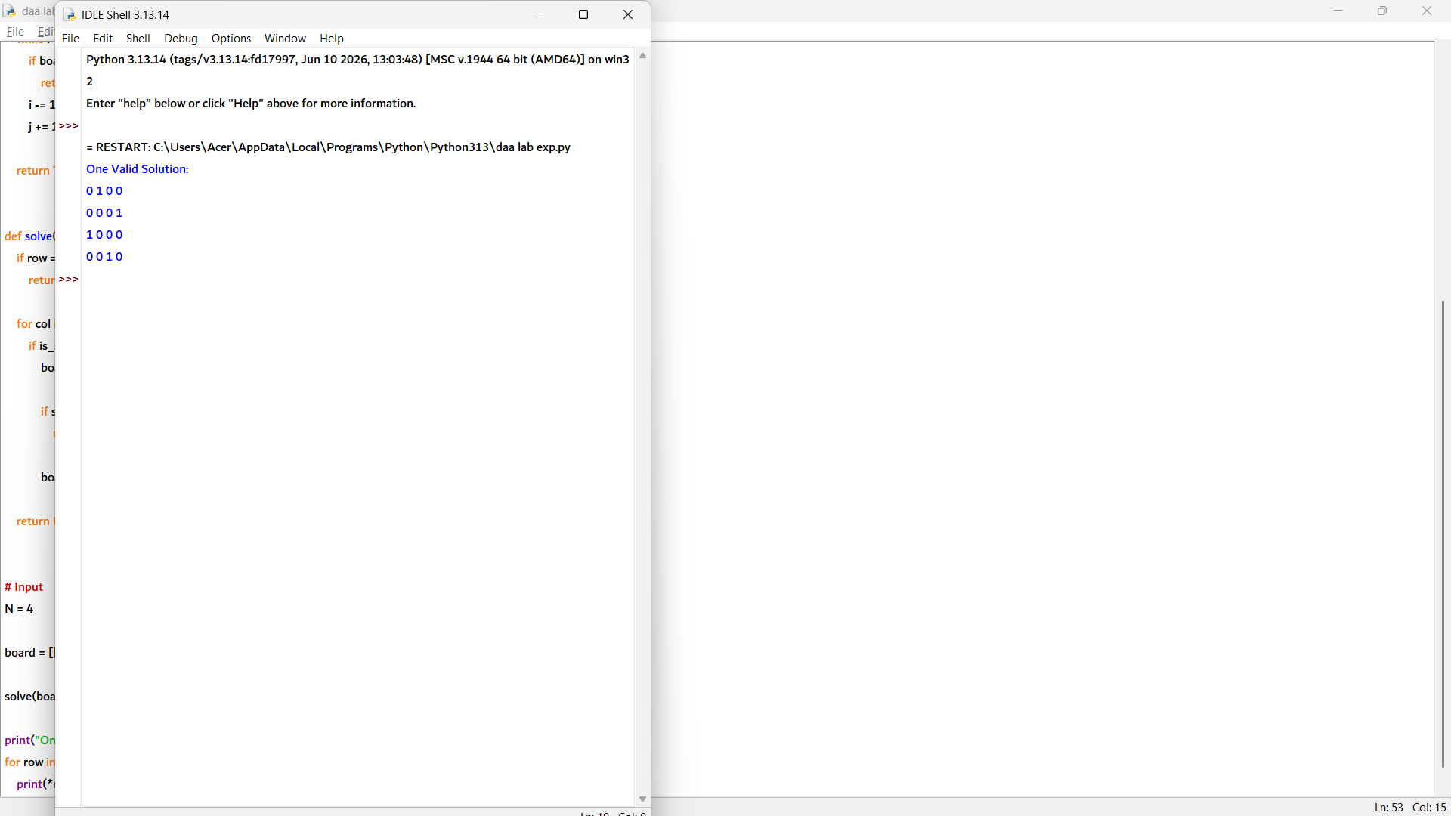

2. def is_safe(board, row, col, n):
# Check column
for i in range(row):
if board[i][col] == 1:
return False

# Check upper-left diagonal
i = row - 1
j = col - 1
while i >= 0 and j >= 0:
if board[i][j] == 1:
return False
i -= 1
j -= 1

# Check upper-right diagonal
i = row - 1
j = col + 1
while i >= 0 and j < n:
if board[i][j] == 1:
return False
i -= 1
j += 1

return True

def solve(board, row, n, solutions):
if row == n:
solutions.append([r[:] for r in board])
return

for col in range(n):
if is_safe(board, row, col, n):
board[row][col] = 1

solve(board, row + 1, n, solutions)

board[row][col] = 0

# Input
N = 4

board = [[0 for _ in range(N)] for _ in range(N)]

solutions = []

solve(board, 0, N, solutions)

print("Total Solutions =", len(solutions))

for i, solution in enumerate(solutions, 1):
print("\nSolution", i, ":")
for row in solution:
print(*row)

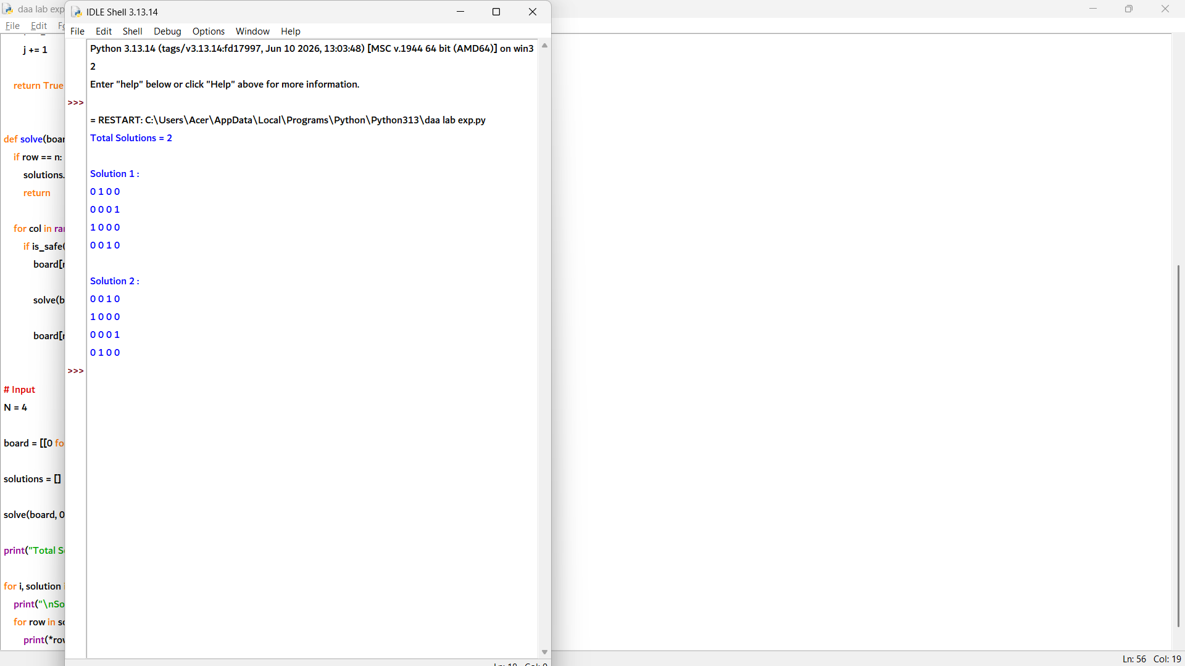

4. def is_safe(board, row, col, num):

# Check row
for i in range(9):
if board[row][i] == num:
return False

# Check column
for i in range(9):
if board[i][col] == num:
return False

# Check 3x3 sub-grid
start_row = row - row % 3
start_col = col - col % 3

for i in range(3):
for j in range(3):
if board[start_row + i][start_col + j] == num:
return False

return True

# Sudoku Board (0 represents empty cells)
board = [
[5,3,0,0,7,0,0,0,0],
[6,0,0,1,9,5,0,0,0],
[0,9,8,0,0,0,0,6,0],
[8,0,0,0,6,0,0,0,3],
[4,0,0,8,0,3,0,0,1],
[7,0,0,0,2,0,0,0,6],
[0,6,0,0,0,0,2,8,0],
[0,0,0,4,1,9,0,0,5],
[0,0,0,0,8,0,0,7,9]
]

# Input
cell = (0,2)
number = 4

row, col = cell

if is_safe(board, row, col, number):
print("Safe Placement: YES")
else:
print("Safe Placement: NO")

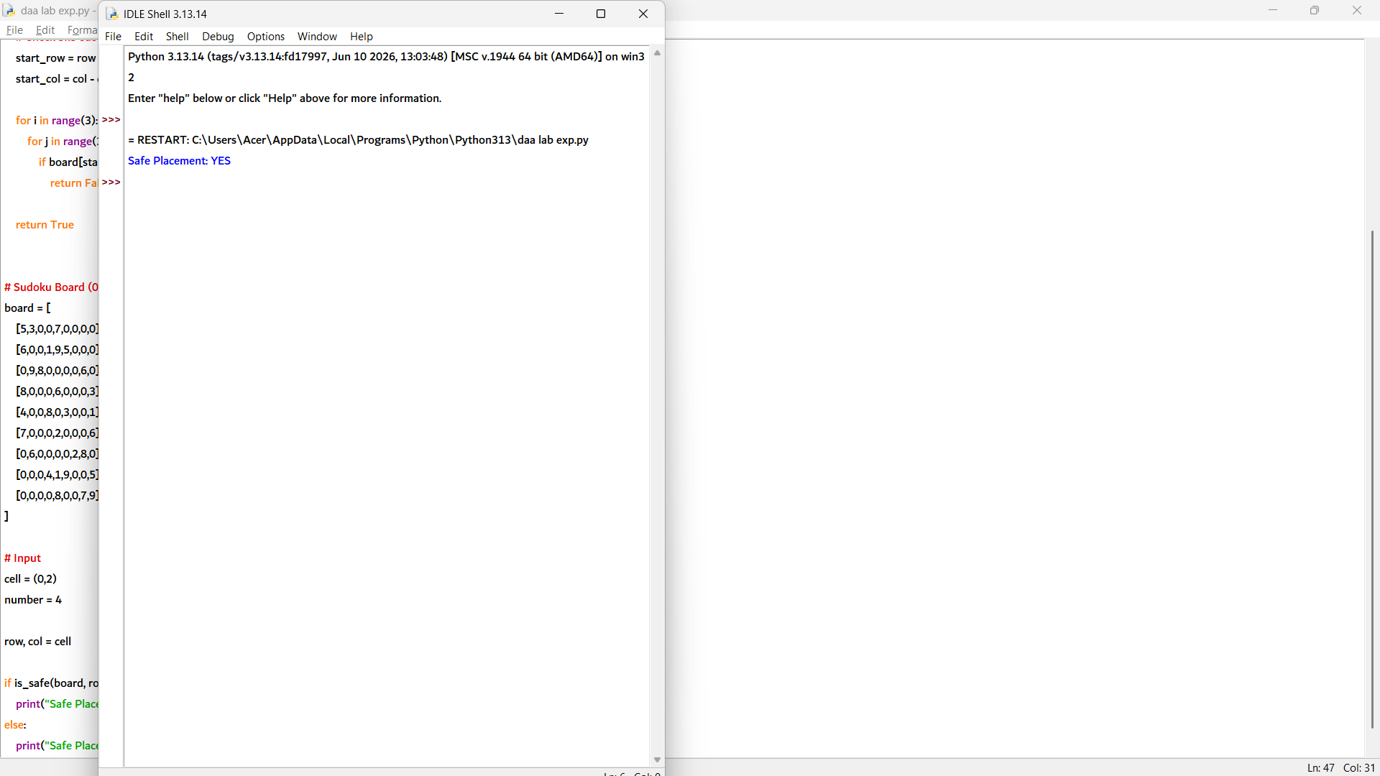

5. def is_safe(board, row, col, num):

# Check row
for i in range(9):
if board[row][i] == num:
return False

# Check column
for i in range(9):
if board[i][col] == num:
return False

# Check 3x3 sub-grid
start_row = row - row % 3
start_col = col - col % 3

for i in range(3):
for j in range(3):
if board[start_row+i][start_col+j] == num:
return False

return True

def solve_sudoku(board):

# Find empty cell
for row in range(9):
for col in range(9):

if board[row][col] == 0:

# Try numbers 1 to 9
for num in range(1, 10):

if is_safe(board, row, col, num):

board[row][col] = num

# Recursively solve
if solve_sudoku(board):
return True

# Backtrack
board[row][col] = 0

return False

return True

# Input Sudoku Grid
board = [
[5,3,0,0,7,0,0,0,0],
[6,0,0,1,9,5,0,0,0],
[0,9,8,0,0,0,0,6,0],
[8,0,0,0,6,0,0,0,3],
[4,0,0,8,0,3,0,0,1],
[7,0,0,0,2,0,0,0,6],
[0,6,0,0,0,0,2,8,0],
[0,0,0,4,1,9,0,0,5],
[0,0,0,0,8,0,0,7,9]
]

solve_sudoku(board)

print("Solved Sudoku Grid:")
for row in board:
print(*row)

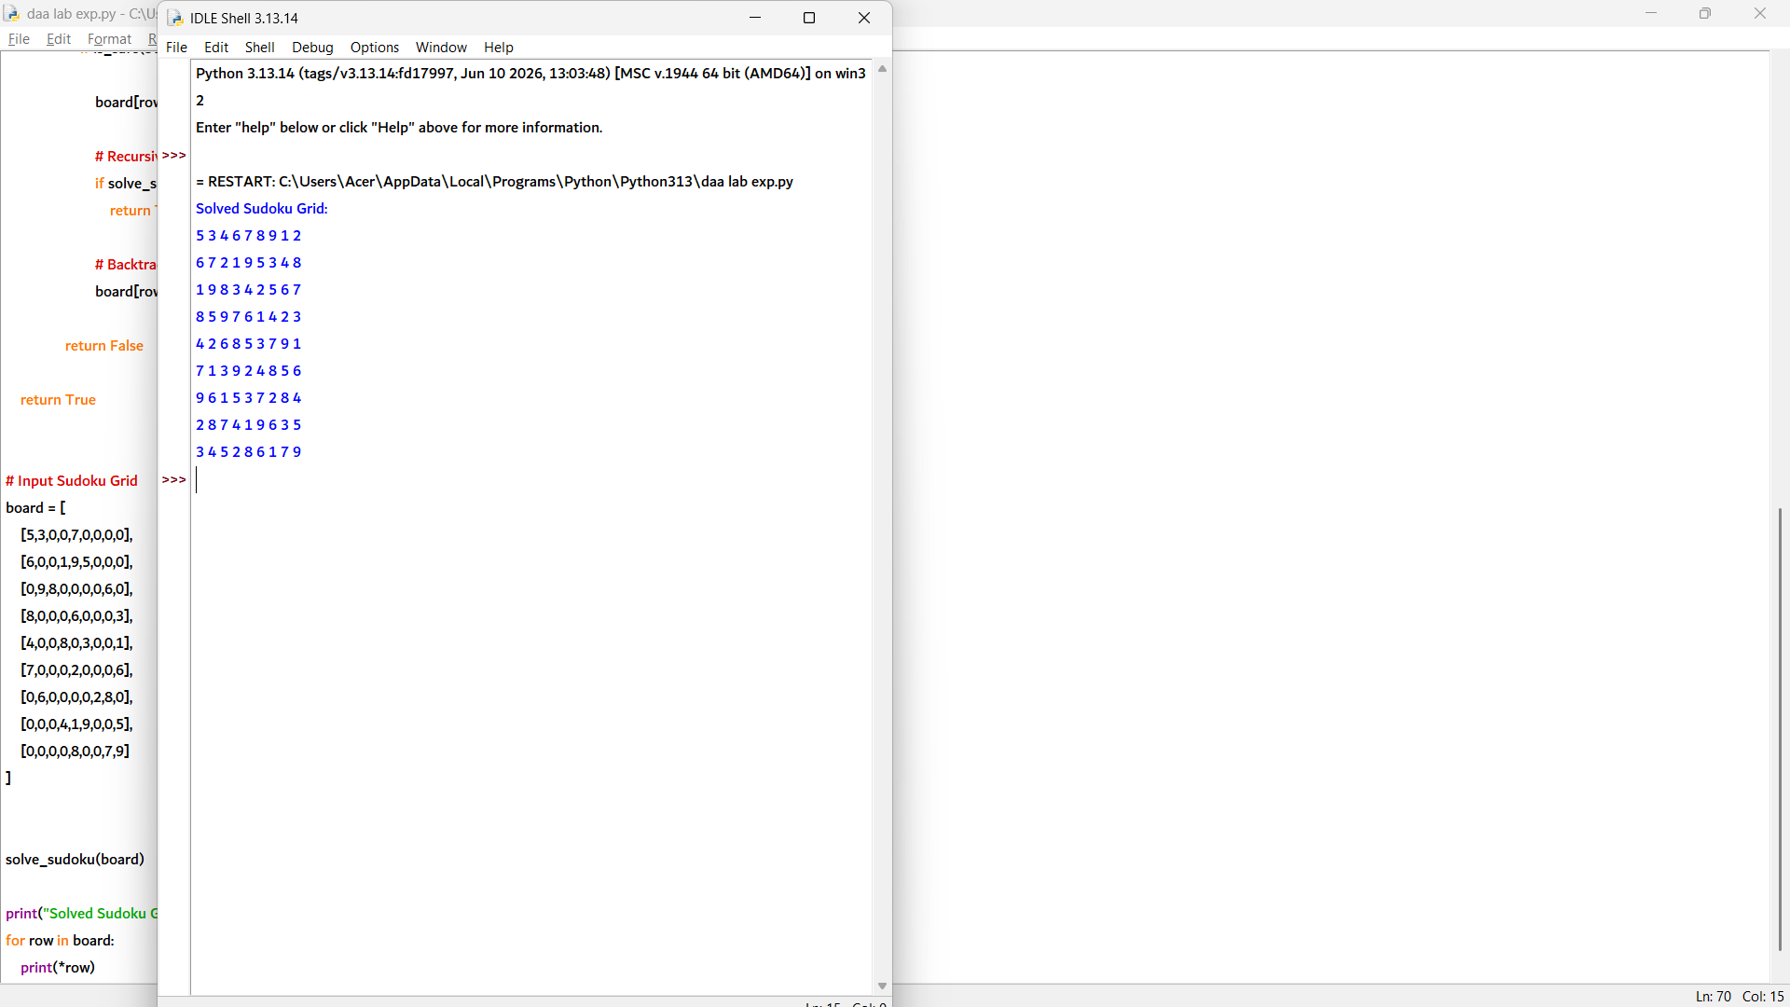

6. def is_safe(board, row, col, num):

# Check row
for i in range(9):
if board[row][i] == num:
return False

# Check column
for i in range(9):
if board[i][col] == num:
return False

# Check 3x3 box
start_row = row - row % 3
start_col = col - col % 3

for i in range(3):
for j in range(3):
if board[start_row+i][start_col+j] == num:
return False

return True

def is_solvable(board):

# Find empty cell
for row in range(9):
for col in range(9):

if board[row][col] == 0:

# Try numbers 1-9
for num in range(1, 10):

if is_safe(board, row, col, num):

board[row][col] = num

if is_solvable(board):
return True

# Backtrack
board[row][col] = 0

return False

# No empty cells means solved
return True

# Input Sudoku Grid
board = [
[5,3,0,0,7,0,0,0,0],
[6,0,0,1,9,5,0,0,0],
[0,9,8,0,0,0,0,6,0],
[8,0,0,0,6,0,0,0,3],
[4,0,0,8,0,3,0,0,1],
[7,0,0,0,2,0,0,0,6],
[0,6,0,0,0,0,2,8,0],
[0,0,0,4,1,9,0,0,5],
[0,0,0,0,8,0,0,7,9]
]

if is_solvable(board):
print("Sudoku Solvable: YES")
print("Solution Found Successfully")
else:
print("Sudoku Solvable: NO")

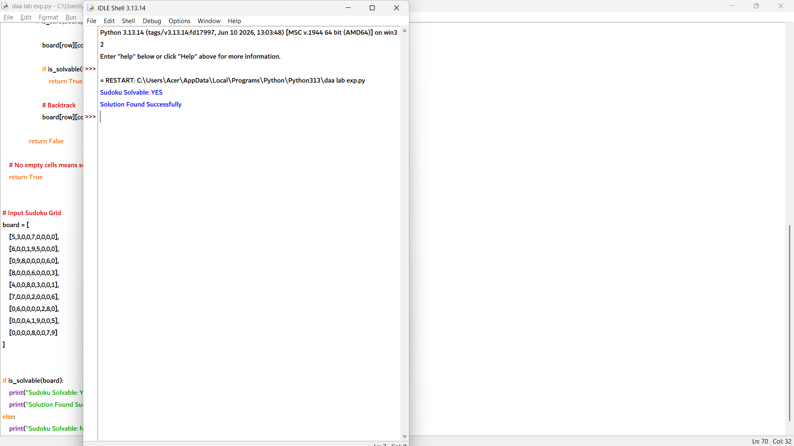

7. def is_safe(vertex, color, graph, colors, n):
for i in range(n):
if graph[vertex][i] == 1 and colors[i] == color:
return False
return True

def graph_coloring(vertex, graph, colors, m, n):

# All vertices colored
if vertex == n:
return True

# Try available colors
for color in range(1, m + 1):

if is_safe(vertex, color, graph, colors, n):
colors[vertex] = color

if graph_coloring(vertex + 1, graph, colors, m, n):
return True

# Backtrack
colors[vertex] = 0

return False

# Input
n = 4
m = 3

graph = [
[0,1,1,1],
[1,0,1,0],
[1,1,0,1],
[1,0,1,0]
]

colors = [0] * n

if graph_coloring(0, graph, colors, m, n):
for i in range(n):
print("Vertex", i, "→ Color", colors[i])
else:
print("No valid coloring possible")

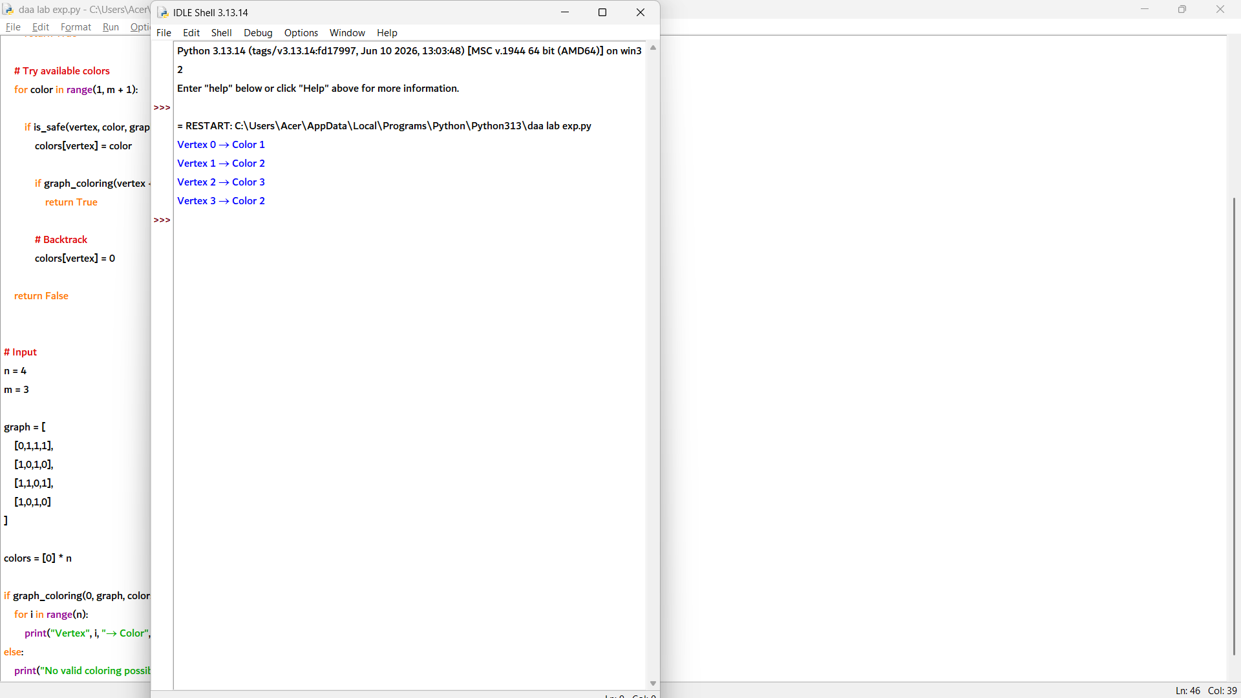

8. def is_safe(vertex, color, graph, colors, n):
for i in range(n):
if graph[vertex][i] == 1 and colors[i] == color:
return False
return True

def can_color(vertex, graph, colors, m, n):

# All vertices colored successfully
if vertex == n:
return True

# Try all colors
for color in range(1, m + 1):

if is_safe(vertex, color, graph, colors, n):
colors[vertex] = color

if can_color(vertex + 1, graph, colors, m, n):
return True

# Backtrack
colors[vertex] = 0

return False

# Input
vertices = 5
m = 3

# Create adjacency matrix
graph = [
[0,1,1,0,0],
[1,0,1,1,0],
[1,1,0,0,1],
[0,1,0,0,0],
[0,0,1,0,0]
]

colors = [0] * vertices

if can_color(0, graph, colors, m, vertices):
print("Graph can be colored using", m, "colors.")
else:
print("Graph cannot be colored using", m, "colors.")

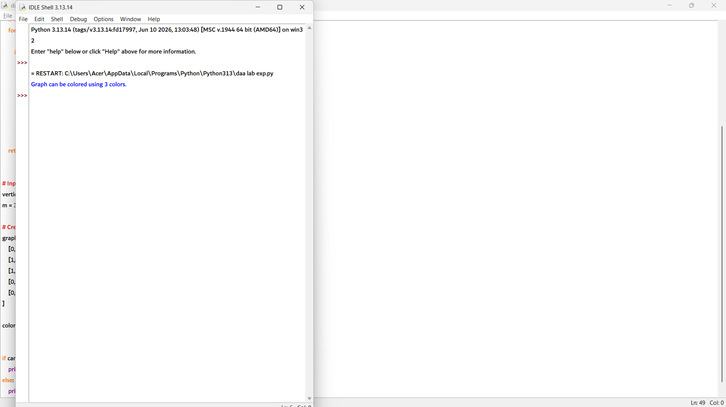

9. def is_safe(vertex, color, graph, colors, n):
for i in range(n):
if graph[vertex][i] == 1 and colors[i] == color:
return False
return True

def can_color(vertex, graph, colors, m, n):
if vertex == n:
return True

for color in range(1, m + 1):
if is_safe(vertex, color, graph, colors, n):
colors[vertex] = color

if can_color(vertex + 1, graph, colors, m, n):
return True

colors[vertex] = 0

return False

def minimum_colors(graph, n):
for m in range(1, n + 1):
colors = [0] * n

if can_color(0, graph, colors, m, n):
return m

return n

# Input: Complete Graph K4
n = 4

graph = [
[0,1,1,1],
[1,0,1,1],
[1,1,0,1],
[1,1,1,0]
]

print("Minimum Colors Required =", minimum_colors(graph, n))

10. def is_safe(v, graph, path, pos):

# Check if vertex is adjacent to previous vertex
if graph[path[pos-1]][v] == 0:
return False

# Check if vertex is already included
if v in path:
return False

return True

def hamiltonian_util(graph, path, pos, n):

# All vertices are included
if pos == n:
# Check if last vertex connects to first vertex
if graph[path[pos-1]][path[0]] == 1:
return True
else:
return False

# Try different vertices
for v in range(1, n):

if is_safe(v, graph, path, pos):

path[pos] = v

if hamiltonian_util(graph, path, pos+1, n):
return True

# Backtrack
path[pos] = -1

return False

def find_hamiltonian_cycle(graph):
n = len(graph)

path = [-1] * n

# Start from vertex 0
path[0] = 0

if hamiltonian_util(graph, path, 1, n):
return path + [path[0]]

return None

# Input
graph = [
[0,1,0,1,0],
[1,0,1,1,1],
[0,1,0,0,1],
[1,1,0,0,1],
[0,1,1,1,0]
]

cycle = find_hamiltonian_cycle(graph)

if cycle:
print("Hamiltonian Cycle Exists:")
print(" → ".join(map(str, cycle)))
else:
print("No Hamiltonian Cycle Exists")

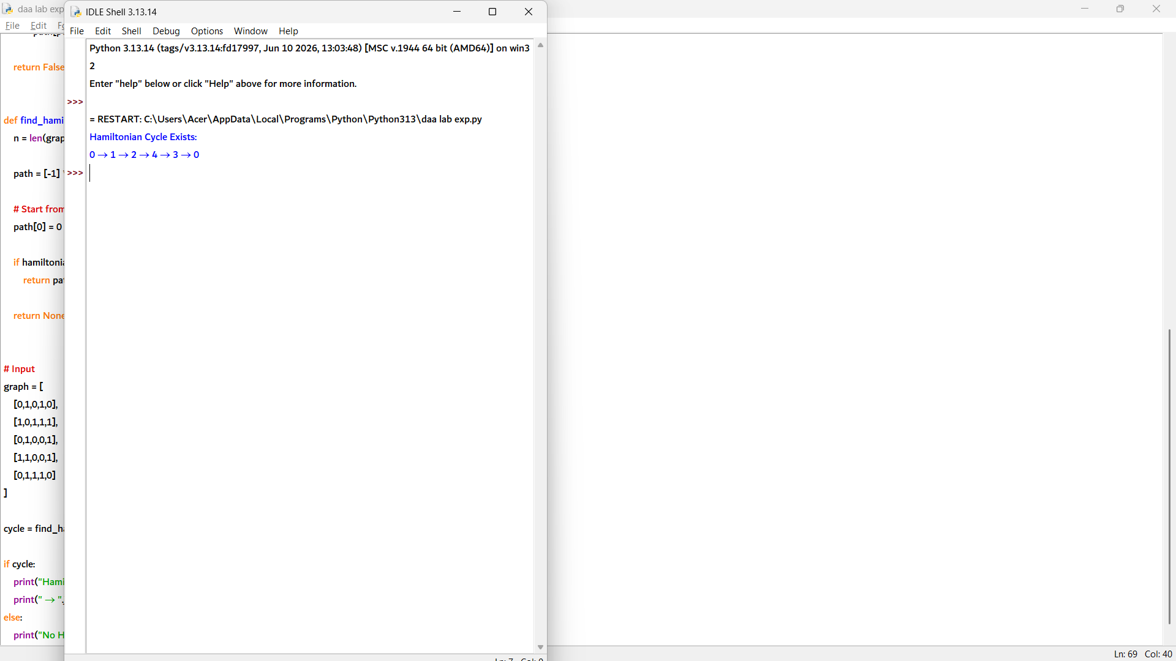

11. def is_safe(v, graph, path, pos):

# Check if vertex is connected to previous vertex
if graph[path[pos - 1]][v] == 0:
return False

# Check if vertex is already included
if v in path:
return False

return True

def hamiltonian_path_util(graph, path, pos, n):

# All vertices are included
if pos == n:
return True

# Try every vertex
for v in range(n):

if is_safe(v, graph, path, pos):

path[pos] = v

if hamiltonian_path_util(graph, path, pos + 1, n):
return True

# Backtrack
path[pos] = -1

return False

def find_hamiltonian_path(graph):
n = len(graph)

path = [-1] * n

# Try each vertex as starting point
for start in range(n):
path[0] = start

if hamiltonian_path_util(graph, path, 1, n):
return path

path = [-1] * n

return None

# Input
n = 5

graph = [
[0,1,0,0,0],
[1,0,1,0,0],
[0,1,0,1,0],
[0,0,1,0,1],
[0,0,0,1,0]
]

path = find_hamiltonian_path(graph)

if path:
print("Hamiltonian Path:")
print(" → ".join(map(str, path)))
else:
print("No Hamiltonian Path Exists")

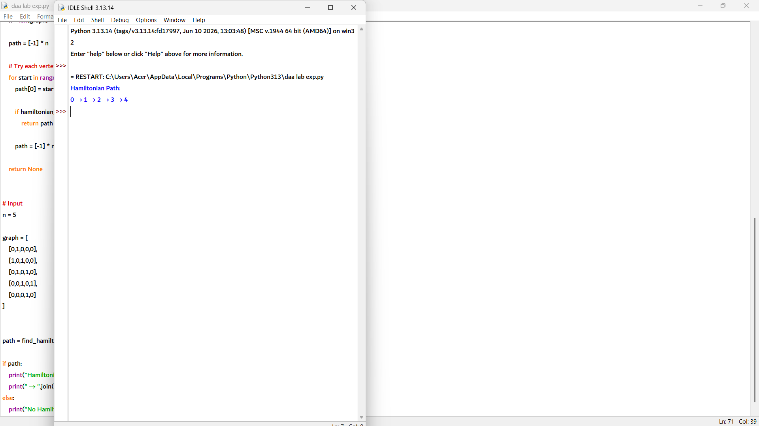

12. def is_safe(v, graph, path, pos):

# Check if vertex is connected to previous vertex
if graph[path[pos - 1]][v] == 0:
return False

# Check if vertex is already used
if v in path:
return False

return True

def find_cycles(graph, path, pos, n, cycles):

# All vertices are included
if pos == n:

# Check edge from last vertex to first vertex
if graph[path[pos - 1]][path[0]] == 1:

cycle = path[:] + [path[0]]

# Avoid duplicate cycles by fixing starting vertex 0
if cycle not in cycles:
cycles.append(cycle)

return

for v in range(1, n):

if is_safe(v, graph, path, pos):

path[pos] = v

find_cycles(graph, path, pos + 1, n, cycles)

path[pos] = -1

# Complete Graph K4
n = 4

graph = [
[0,1,1,1],
[1,0,1,1],
[1,1,0,1],
[1,1,1,0]
]

path = [0] + [-1] * (n - 1)

cycles = []

find_cycles(graph, path, 1, n, cycles)

print("Hamiltonian Cycles:")

for cycle in cycles:
print(" → ".join(map(str, cycle)))

print("Total Cycles =", len(cycles))

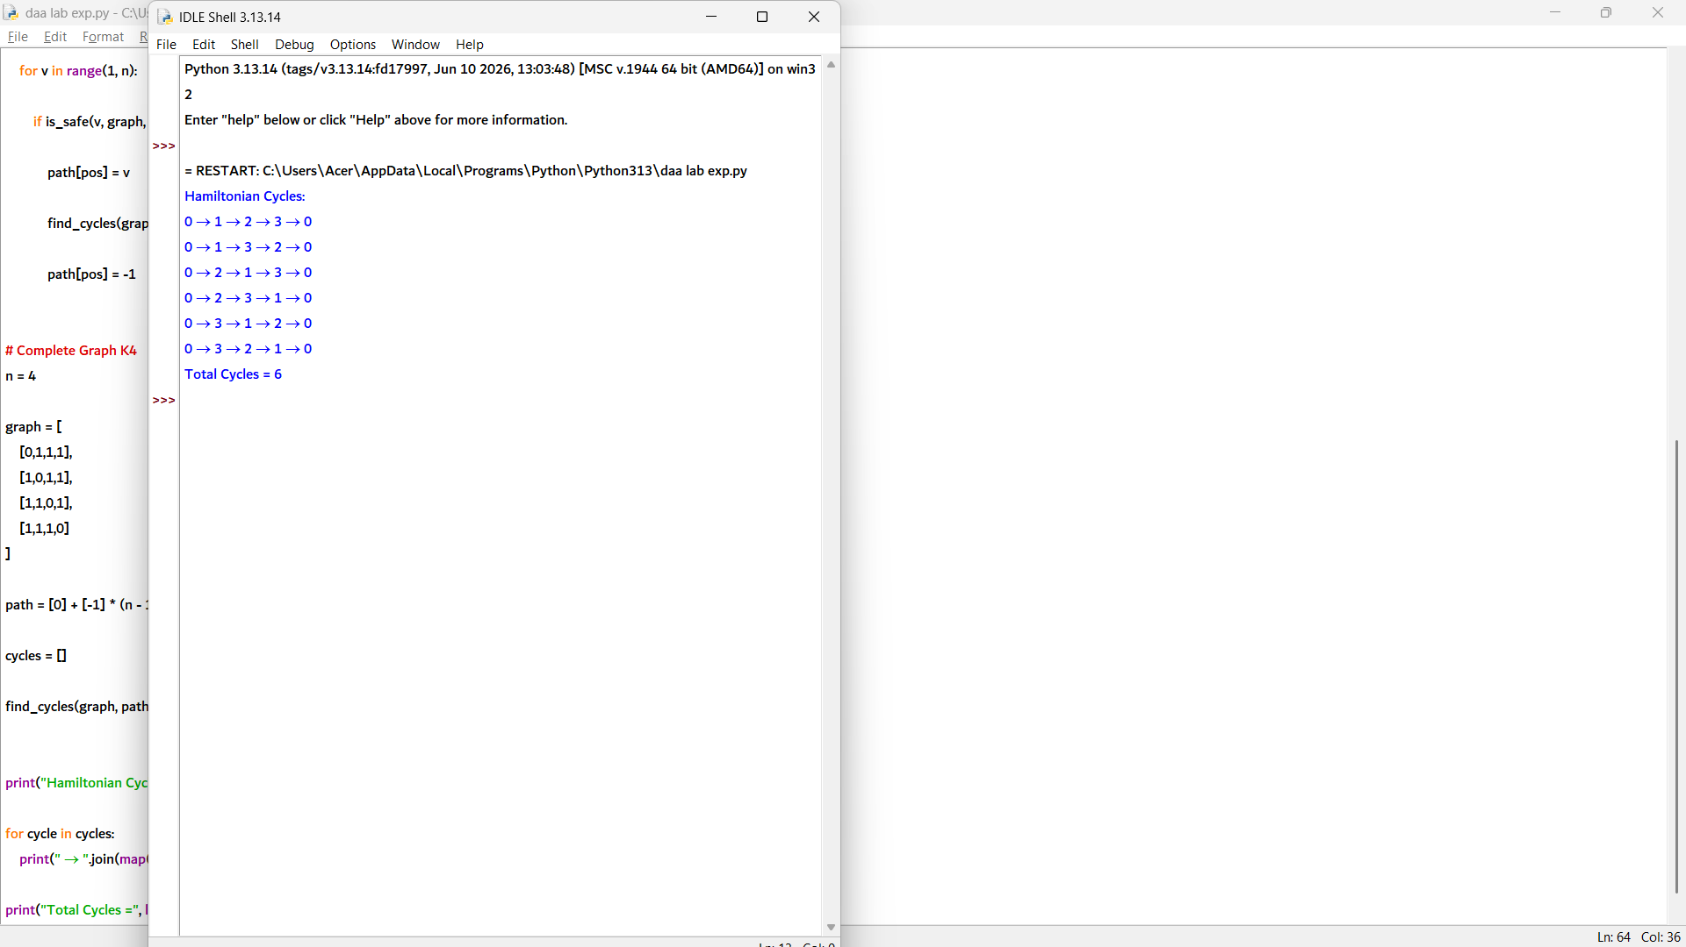

13. def approximate_vertex_cover(vertices, edges):

cover = set()
remaining_edges = edges[:]

while remaining_edges:

# Pick first edge
u, v = remaining_edges[0]

# Add both endpoints to vertex cover
cover.add(u)
cover.add(v)

# Remove all edges covered by u or v
new_edges = []

for a, b in remaining_edges:
if a != u and a != v and b != u and b != v:
new_edges.append((a, b))

remaining_edges = new_edges

return cover

# Input
vertices = 5

edges = [
(0,1),
(0,2),
(1,3),
(2,4)
]

cover = approximate_vertex_cover(vertices, edges)

print("Approximate Vertex Cover:")
print(cover)

print("Cover Size =", len(cover))

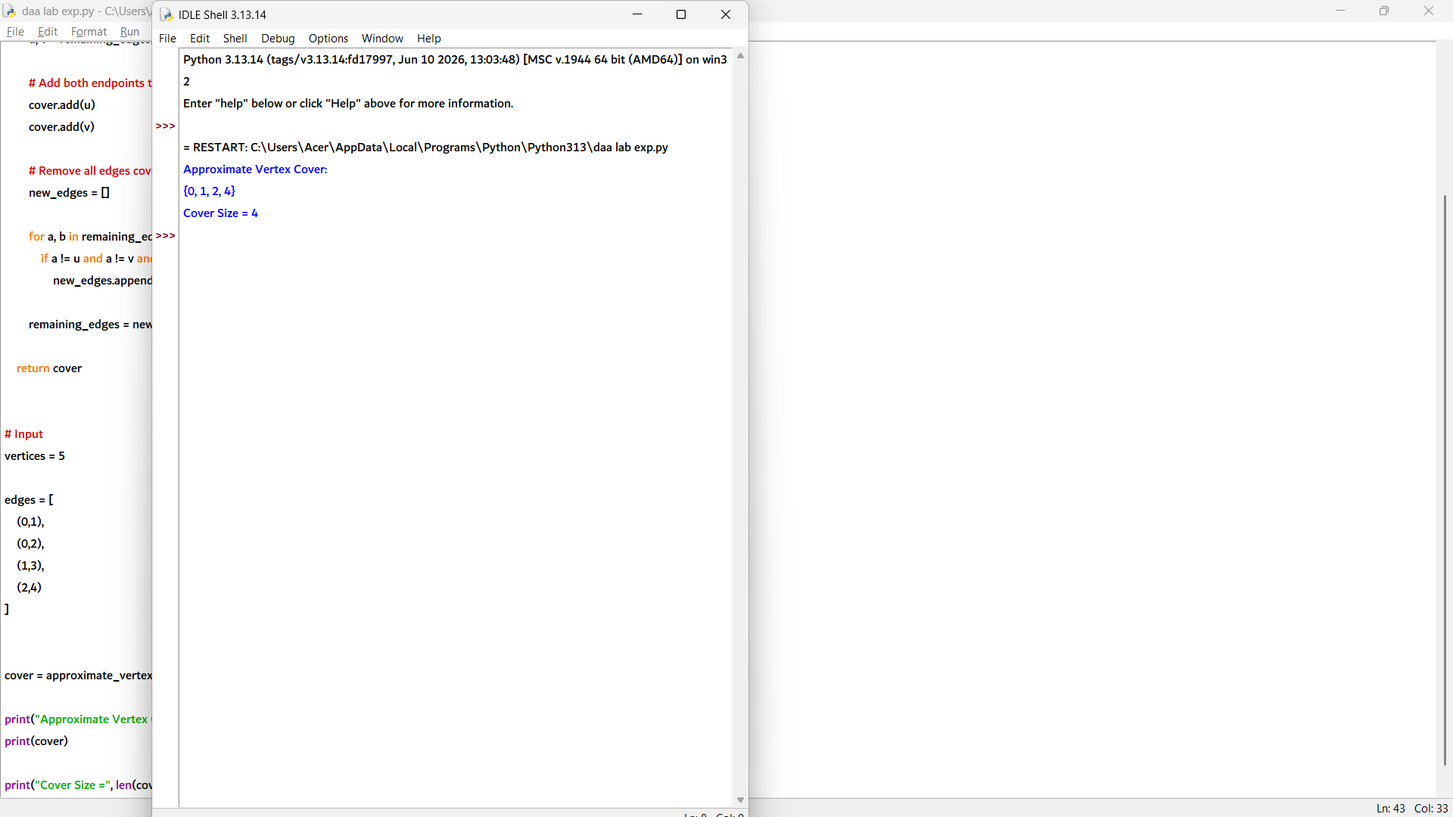

14. from itertools import combinations

# Check if a set is a vertex cover
def is_vertex_cover(vertices, edges, cover):
for u, v in edges:
if u not in cover and v not in cover:
return False
return True

# Find exact minimum vertex cover
def exact_vertex_cover(vertices, edges):
n = len(vertices)

for size in range(n + 1):
for subset in combinations(vertices, size):
if is_vertex_cover(vertices, edges, set(subset)):
return set(subset)

# Approximate vertex cover using greedy edge selection
def approximate_vertex_cover(edges):

cover = set()
remaining = edges[:]

while remaining:

u, v = remaining[0]

cover.add(u)
cover.add(v)

new_edges = []

for a, b in remaining:
if a != u and a != v and b != u and b != v:
new_edges.append((a, b))

remaining = new_edges

return cover

# Input
vertices = [0,1,2,3,4,5]

edges = [
(0,1),
(0,2),
(1,3),
(2,4),
(3,5)
]

# Exact solution
exact = exact_vertex_cover(vertices, edges)

# Approximate solution
approx = approximate_vertex_cover(edges)

ratio = len(approx) / len(exact)

print("Exact Vertex Cover Size =", len(exact))
print("Approximate Vertex Cover Size =", len(approx))
print("Approximation Ratio =", round(ratio, 2))

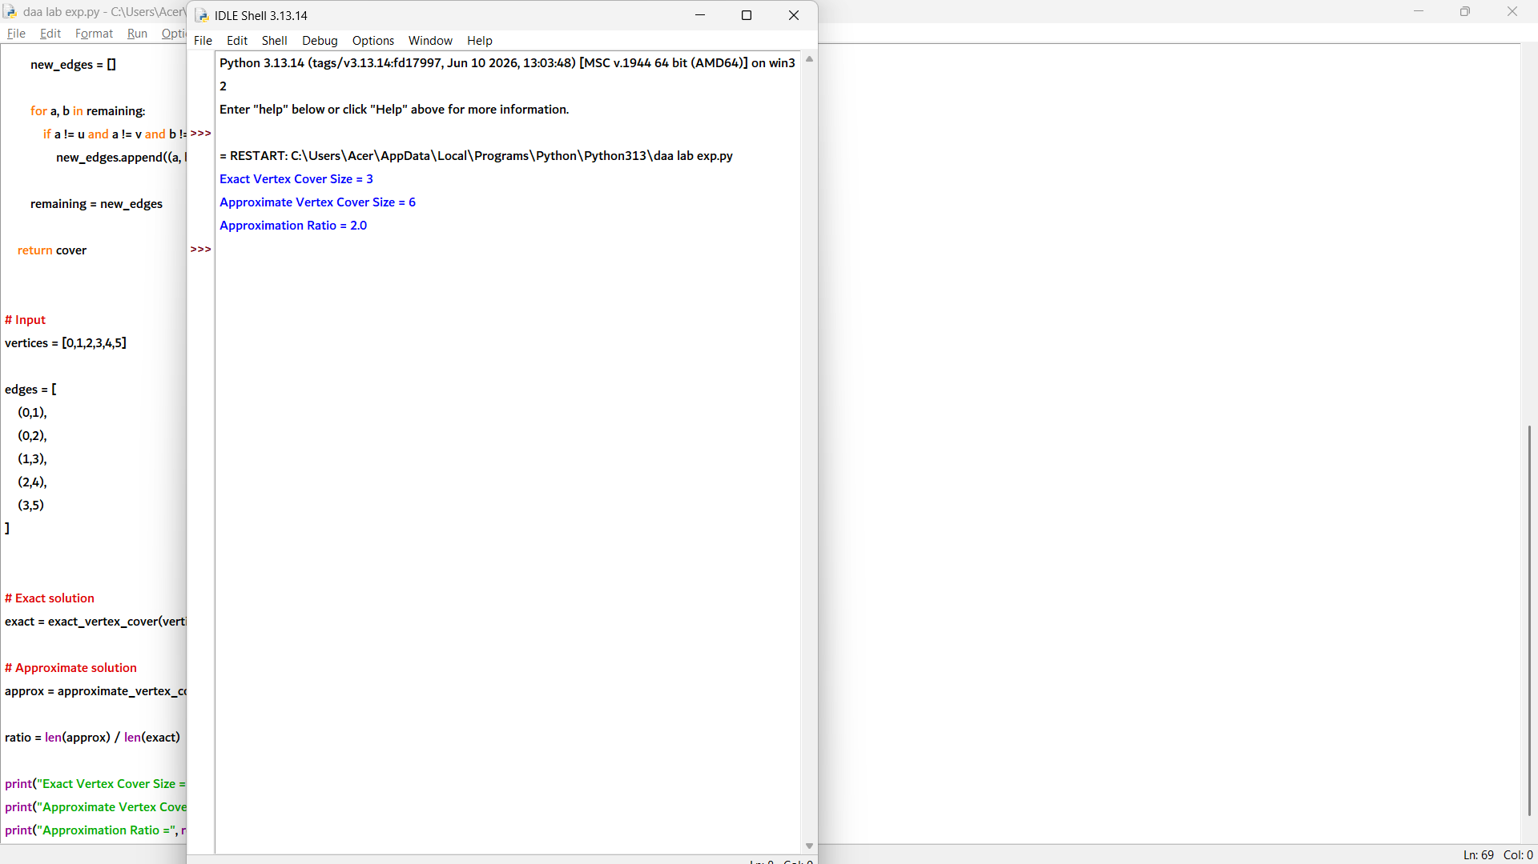

15. def first_fit_decreasing(items, capacity):

# Sort items in decreasing order
items.sort(reverse=True)

bins = []

for item in items:

placed = False

# Try to place item in existing bins
for i in range(len(bins)):

if sum(bins[i]) + item <= capacity:
bins[i].append(item)
placed = True
break

# Create new bin if item cannot fit
if not placed:
bins.append([item])

return items, bins

# Input
capacity = 10
items = [2,5,4,7,1,3,8]

sorted_items, bins = first_fit_decreasing(items, capacity)

print("Sorted Items:")
print(sorted_items)

for i, b in enumerate(bins, 1):
print("Bin", i, ":", *b)

print("Total Bins Used =", len(bins))

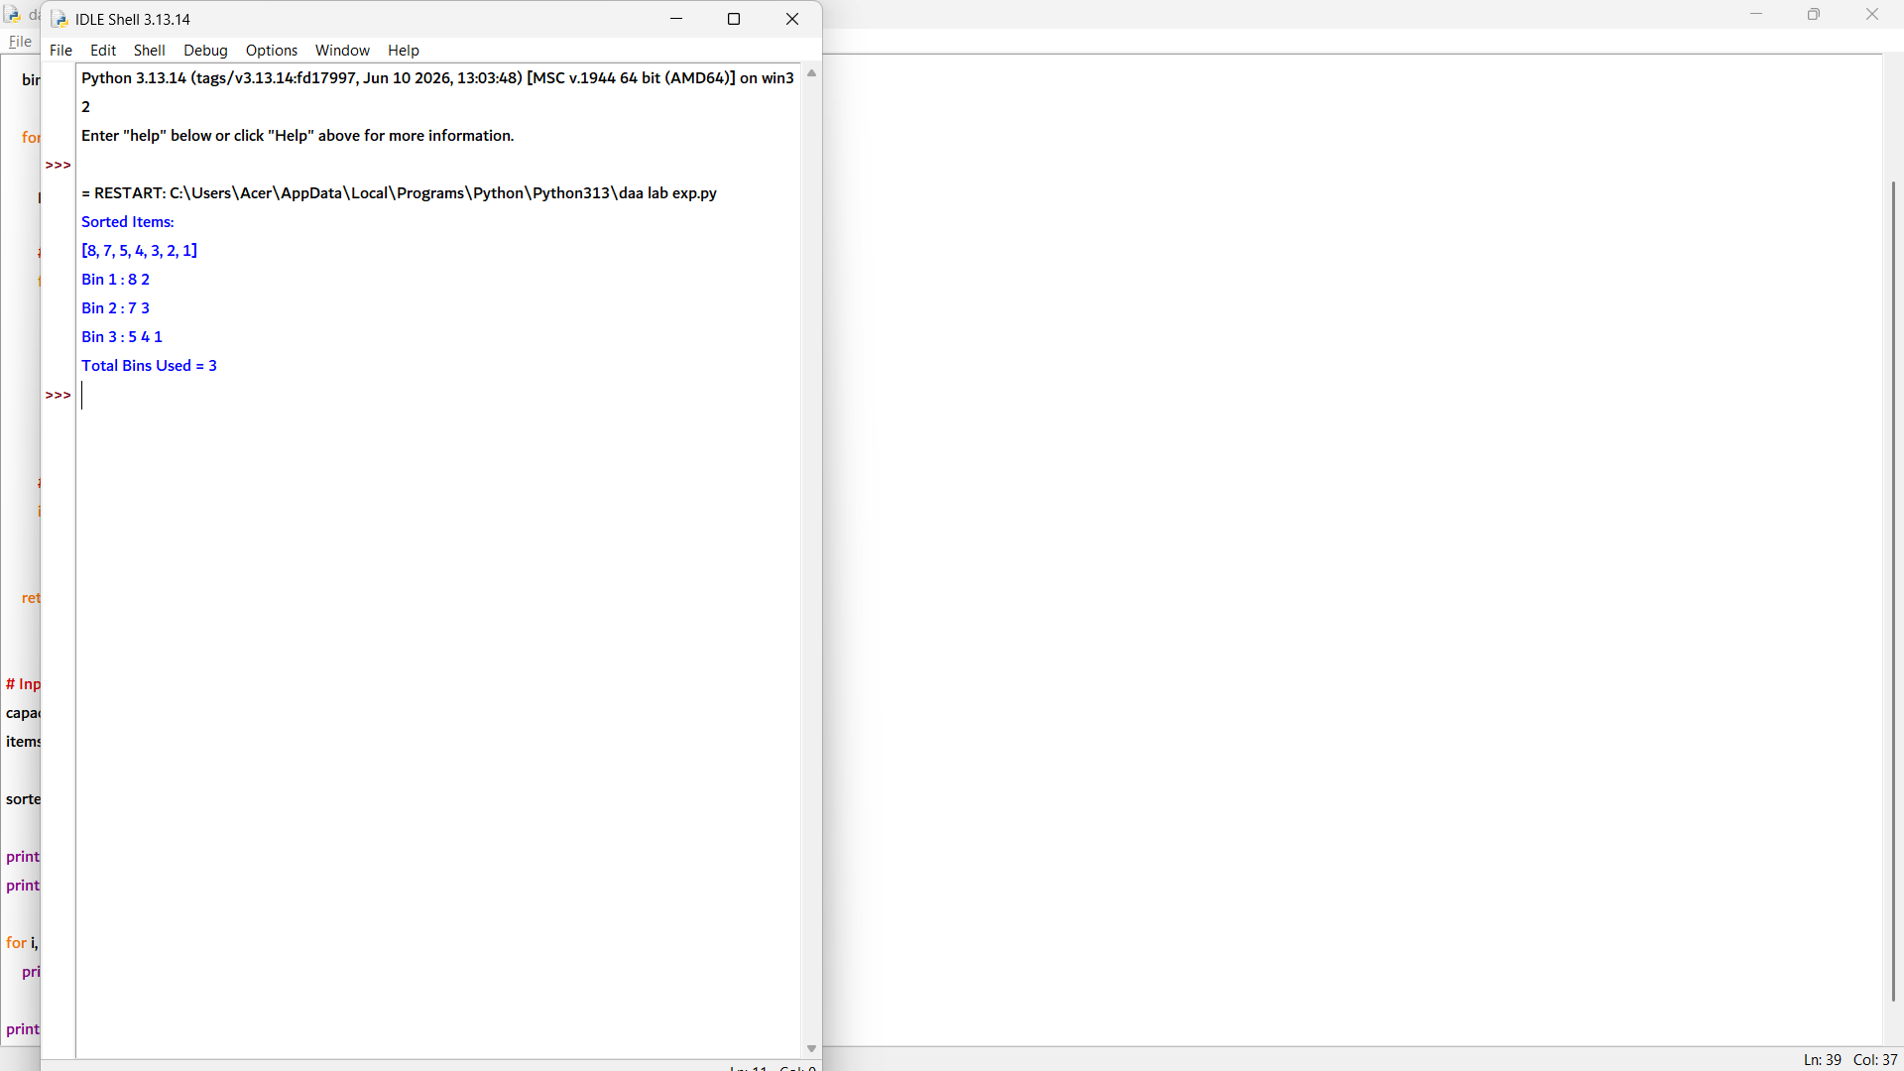

16. def solve_nqueens(n):

board = [["." for _ in range(n)] for _ in range(n)]

cols = [False] * n
diag1 = [False] * (2 * n - 1) # row - col + n - 1
diag2 = [False] * (2 * n - 1) # row + col

def place_queen(row):

# All queens placed
if row == n:
return True

for col in range(n):

if not cols[col] and not diag1[row-col+n-1] and not diag2[row+col]:

# Place queen
board[row][col] = "Q"
cols[col] = True
diag1[row-col+n-1] = True
diag2[row+col] = True

if place_queen(row + 1):
return True

# Backtrack
board[row][col] = "."
cols[col] = False
diag1[row-col+n-1] = False
diag2[row+col] = False

return False

if place_queen(0):
return board
else:
return None

# Input
N = 8

solution = solve_nqueens(N)

if solution:
print("One Valid Solution:")
for row in solution:
print(" ".join(row))
else:
print("No Solution Exists")

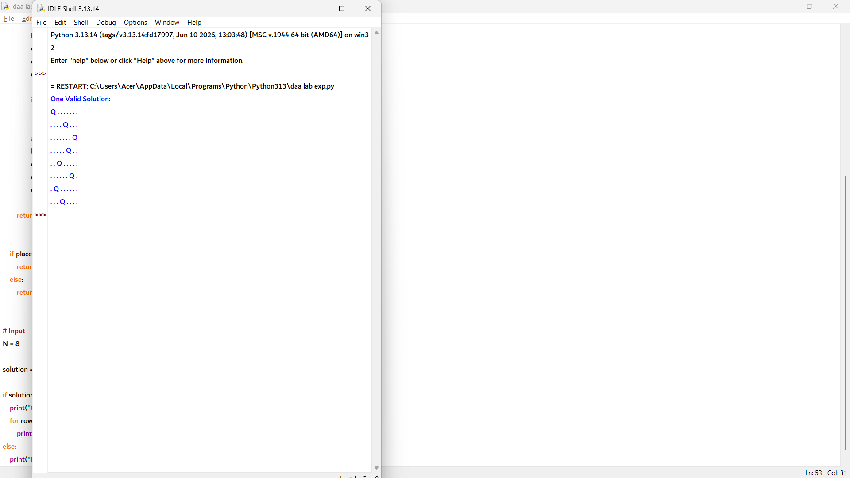

17. def is_safe(board, row, col, num):

# Check row
for i in range(9):
if board[row][i] == num:
return False

# Check column
for i in range(9):
if board[i][col] == num:
return False

# Check 3x3 box
start_row = row - row % 3
start_col = col - col % 3

for i in range(3):
for j in range(3):
if board[start_row+i][start_col+j] == num:
return False

return True

def count_solutions(board):

count = 0

def solve():

nonlocal count

# Find empty cell
for row in range(9):
for col in range(9):

if board[row][col] == 0:

# Try numbers 1-9
for num in range(1, 10):

if is_safe(board, row, col, num):

board[row][col] = num

solve()

# Backtrack
board[row][col] = 0

return

# One complete solution found
count += 1

solve()
return count

# Input Sudoku Grid
board = [
[5,3,0,0,7,0,0,0,0],
[6,0,0,1,9,5,0,0,0],
[0,9,8,0,0,0,0,6,0],
[8,0,0,0,6,0,0,0,3],
[4,0,0,8,0,3,0,0,1],
[7,0,0,0,2,0,0,0,6],
[0,6,0,0,0,0,2,8,0],
[0,0,0,4,1,9,0,0,5],
[0,0,0,0,8,0,0,7,9]
]

solutions = count_solutions(board)

print("Number of Valid Solutions =", solutions)

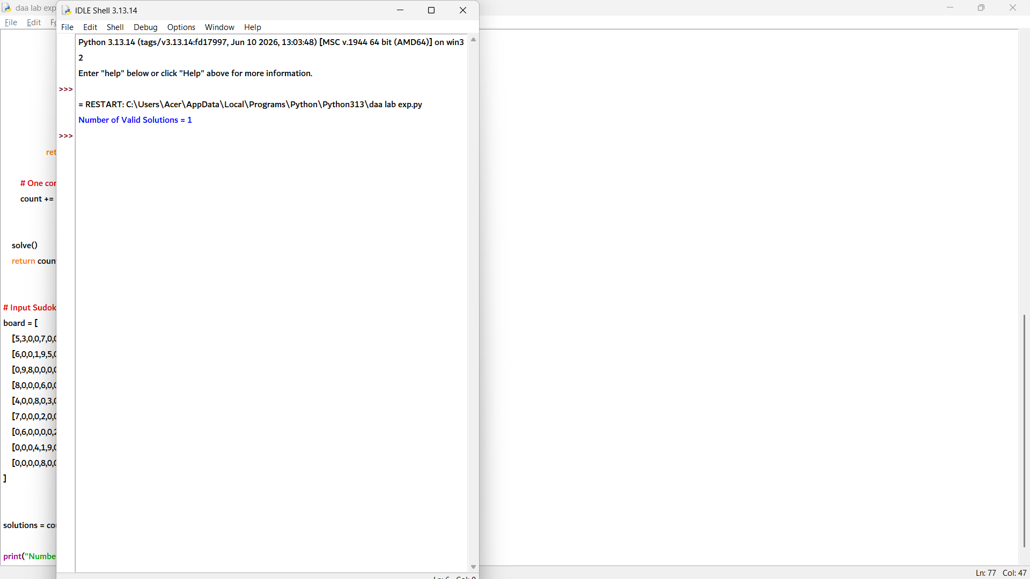

18. def greedy_coloring(vertices, edges):

# Create adjacency list
graph = [[] for _ in range(vertices)]

for u, v in edges:
graph[u].append(v)
graph[v].append(u)

colors = [-1] * vertices

# Assign colors vertex by vertex
for v in range(vertices):

# Find colors used by adjacent vertices
used = set()

for neighbor in graph[v]:
if colors[neighbor] != -1:
used.add(colors[neighbor])

# Assign smallest available color
color = 1
while color in used:
color += 1

colors[v] = color

return colors

# Input
vertices = 5

edges = [
(0,1),
(0,2),
(1,2),
(1,3),
(2,4)
]

colors = greedy_coloring(vertices, edges)

print("Greedy Coloring:")

for i in range(vertices):
print("Vertex", i, "→ Color", colors[i])

print("Total Colors Used =", max(colors))

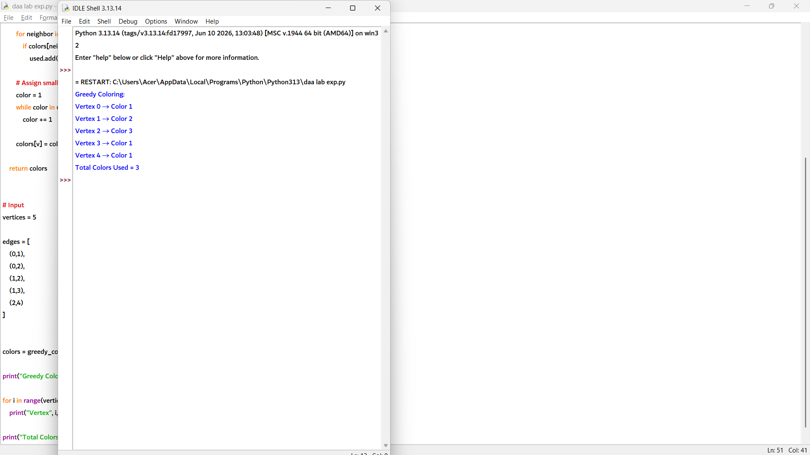

19. def approximate_vertex_cover(edges):

cover = set()
remaining_edges = edges[:]

while remaining_edges:

# Pick an uncovered edge
u, v = remaining_edges[0]

# Add both endpoints
cover.add(u)
cover.add(v)

# Remove all edges covered by u or v
new_edges = []

for a, b in remaining_edges:
if a != u and a != v and b != u and b != v:
new_edges.append((a, b))

remaining_edges = new_edges

return cover

# Input
vertices = 6

edges = [
(0,1),
(0,2),
(1,3),
(2,4),
(4,5)
]

cover = approximate_vertex_cover(edges)

print("Approximate Vertex Cover:")
print(cover)

print("Cover Size =", len(cover))

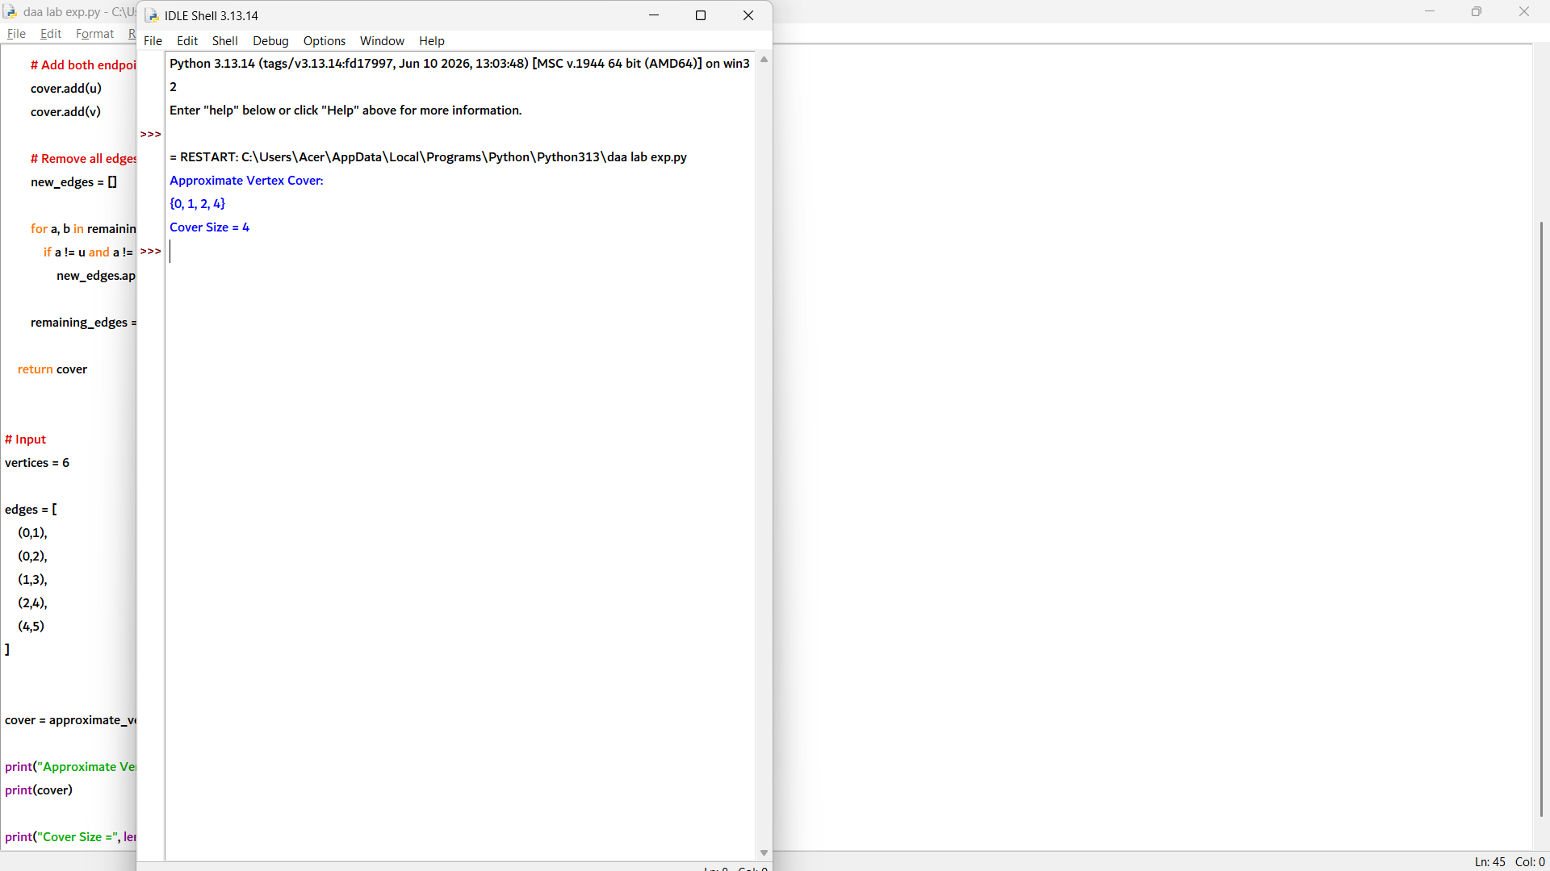

20. def best_fit(items, capacity):

bins = []

for item in items:

best_bin = -1
min_space = capacity + 1

# Find the bin with least remaining space
for i in range(len(bins)):
remaining = capacity - sum(bins[i])

if item <= remaining and (remaining - item) < min_space:
min_space = remaining - item
best_bin = i

# Place item
if best_bin == -1:
bins.append([item])
else:
bins[best_bin].append(item)

return bins

# Input
capacity = 10
items = [2, 5, 4, 7, 1, 3, 8]

bins = best_fit(items, capacity)

for i, b in enumerate(bins, 1):
print("Bin", i, ":", *b)

print("Total Bins Used =", len(bins))

